COAL – Lab 11 – Lab tasks

Task 1:
INCLUDE Irvine32.inc

.data
basicSal DWORD 50000
allow DWORD 15000

.code
main PROC
push allow
push basicSal

call CalcSalary

call WriteInt
call Crlf

exit
main ENDP

CalcSalary PROC
push ebp
mov ebp, esp

mov eax, [ebp+8]
add eax, [ebp+12]
pop ebp
ret 8
CalcSalary ENDP

END main

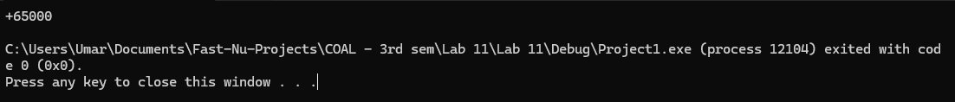

Task 2:
INCLUDE Irvine32.inc

.data
cycleTime DWORD 30
waterLevel DWORD 5
temp DWORD 40

.code
main PROC
push temp
push waterLevel
push cycleTime
call WashCycle
exit
main ENDP

WashCycle PROC USES ebx ecx edx
push ebp
mov ebp, esp

mov ebx, [ebp+20]
mov ecx, [ebp+24]
mov edx, [ebp+28]

imul ebx, ecx
add ebx, edx
mov eax, ebx

call WriteInt
call Crlf

pop ebp
ret 12
WashCycle ENDP

END main

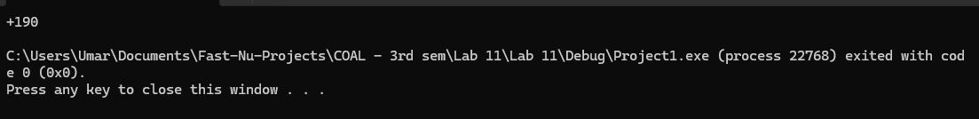
Task 3:
INCLUDE Irvine32.inc

.data
bookCounts DWORD 12, 8, 5, 20, 14
numCats DWORD 5

.code
main PROC
push numCats
push OFFSET bookCounts
call TotalBooks
call WriteInt
call Crlf
exit
main ENDP

TotalBooks PROC
push ebp
mov ebp, esp
mov esi, [ebp+8]
mov ecx, [ebp+12]
xor eax, eax

L1:
add eax, [esi]
add esi, 4
loop L1

pop ebp
ret 8
TotalBooks ENDP

END main

